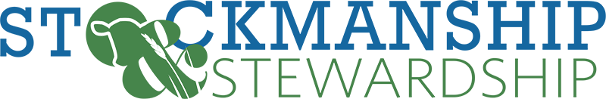
Stockmanship & Stewardship Tentative Agenda
Norfolk, Nebraska
Lifelong Learning Center & Northeast Community College Ag Complex

Tuesday June 13:
Starting Location: Lifelong Learning Center

7:00 AM Registration, Coffee, Doughnuts

8:00 AM Welcome - Nebraska BQA / Merck/ NCBA

8:10 AM Kickoff Speaker

8:50 AM Move to Breakouts

9:00 AM Breakout Sessions

12:00 PM Lunch sponsored by Certified Angus Beef

12:30 PM Certified Angus Beef “Cut the Bull” Presentation

1:00 PM Certified Angus Beef Panel Discussion

1:50 PM Move to Demo Arena
Northeast Community Ag Complex

2:00 PM Demo Arena – Cattle Handling

5:00 PM Closing activities and Adjourn

*Please note, this is currently a working agenda, as speakers and topics become finalized this will be updated frequently.*

