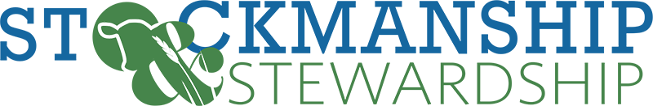
Stockmanship & Stewardship Tentative Agenda
Fort Collins, Colorado
ARDEC & JBS Innovation Center

Friday August 18:
Starting Location: CSU Agriculture Research, Development and Education Center (ARDEC)

8:00 am Registration
9:00 am Welcome and Introductions
9:15 am Part 1: The Role of the Cattle Transporter
Cattle Fitness for Transport
Cattle and Human Safety
Meat Quality Outcomes
Biosecurity

10:15 am Walk to pens
10:30 am Live Cattle Demonstrations
Cattle transportation – loading and unloading, trailer design and safety 6
Trailer Walk-Through
Fitness for Transport, Cattle Observation Scoring – Locomotion, Body Condition, other defects or health concerns

12:30 pm BBQ Beef Lunch
1:30 pm Depart for JBS Global Food Innovation Center Afternoon Sessions
2:30 pm Part 2: Carcass Evaluation
CSU Meat Sciences Professor(s)
Carcass Evaluation and Fabrication (Bruise observation, trim and weight)

3:30 pm Panel Discussion: Importance of Transportation in Cattle Marketing & Procurement
Packer Rep
Feedlot Rep
Livestock Auction Rep

4:45 pm BQAT Quiz
5:00 pm Adjourn (Optional JBS Global Food Innovation Center tour)

*Please note, this is currently a working agenda, as speakers and topics become finalized this will be updated frequently.*

